Customer Registration

Register form will popup when

1. accessing Mashaweer web site
2. at any time press on Register link at the to of the page

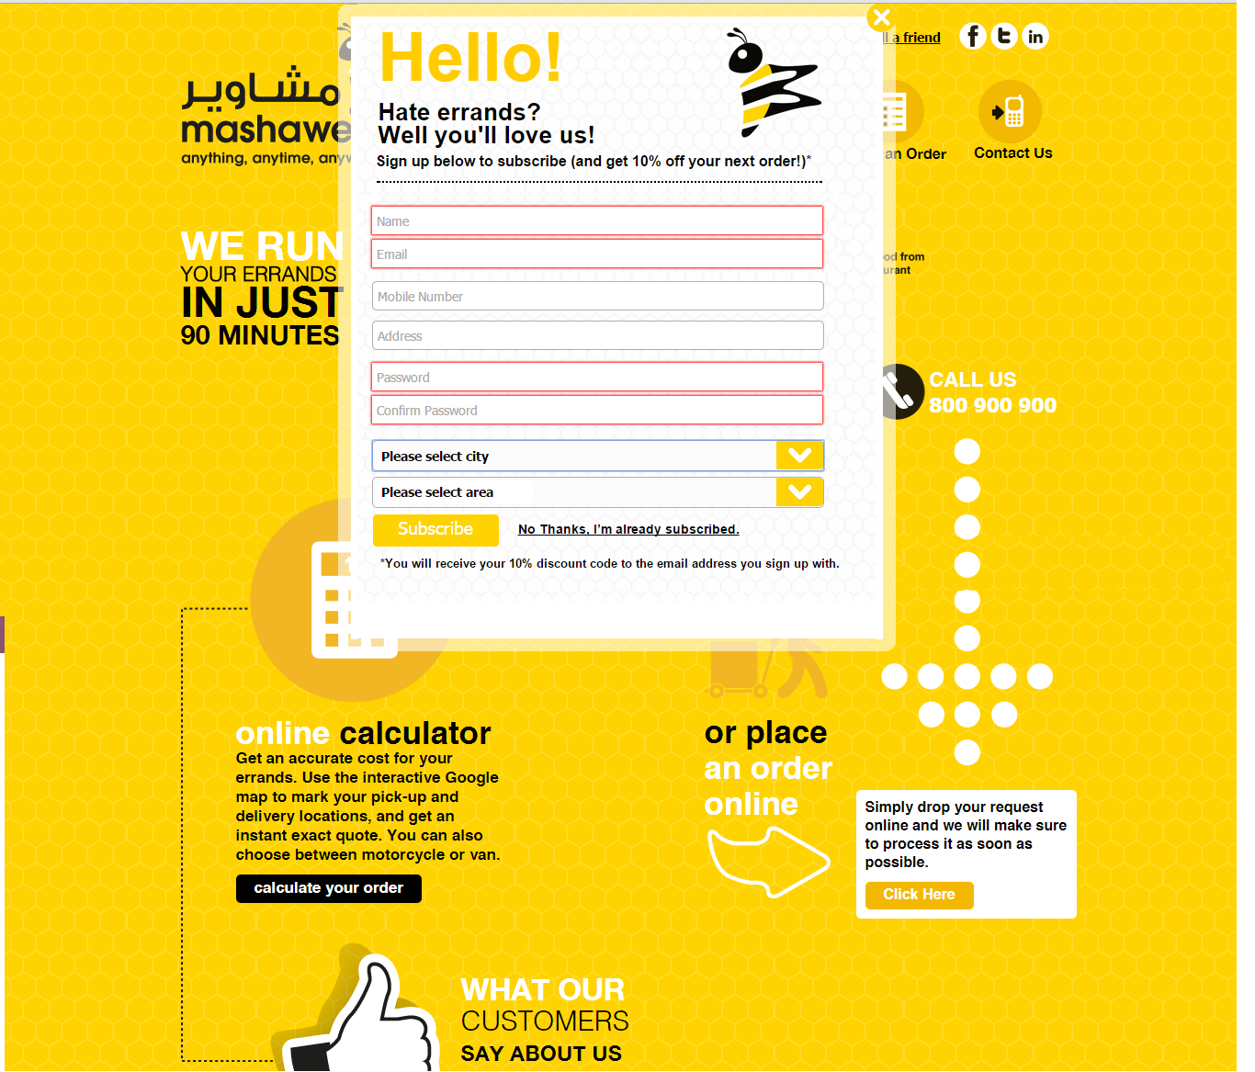

Customer can press Login to login to our web site and it will requested to provide registered email and address

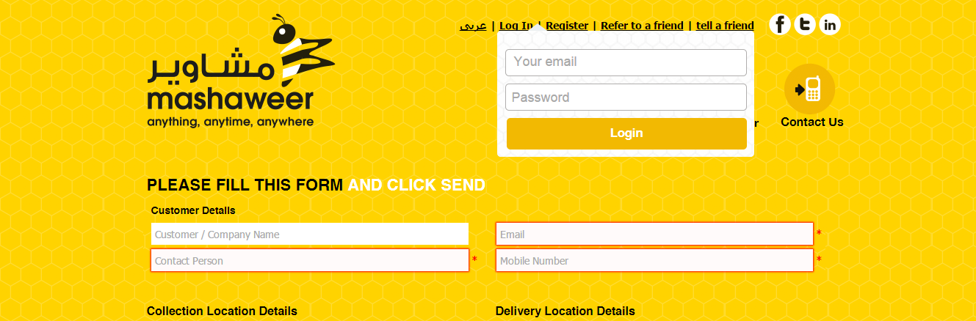

- After login it redirects to order page and fill customer fields with registered data and show welcome sentence on the right of page .

Place Order From :

Modified by adding new fields

* Promotion code
* Value of promotion discount
* Grand Total , Total cost after discount

Accepted promotion code : Valid promotion code – provided to the same email address used to place the order – used within validity period.

In order page I added promotion code .

- If user that make order not registered before he will get message to tell him to register and get discount .

- If user that make order registered before he will get message that if he refer to friend he will get bonus .

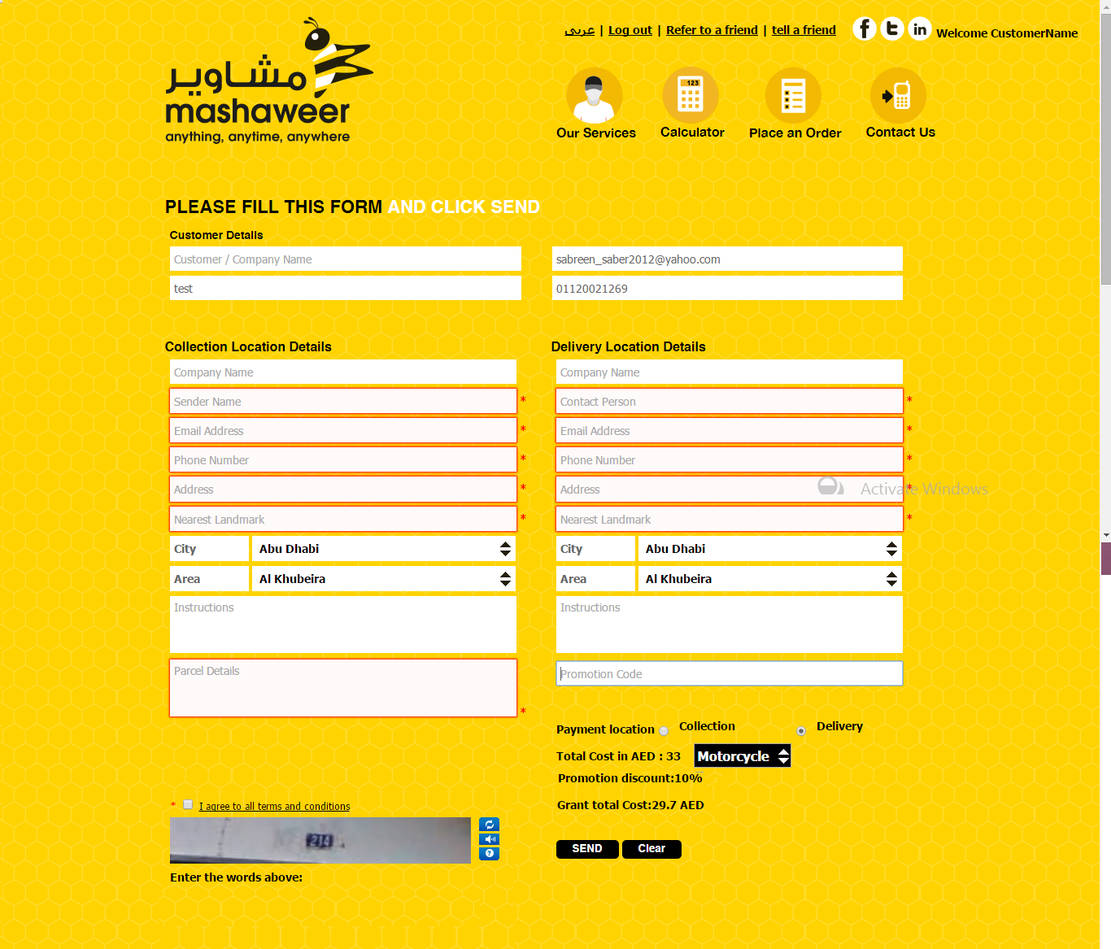

Refer to Friend:

When user refer to friend and put his friend email, his friend get message to register and place an order to get discount and promotion code,If he place an order ,The person that made referring to friend will get email to tell him that he get bonus , promotion code , discount percentage and expired date of promotion if this person not registered the email will tell him to make register to get discount also. Either way the person is registered or not he will get bonus if he make refer to friend and his friend place an order.

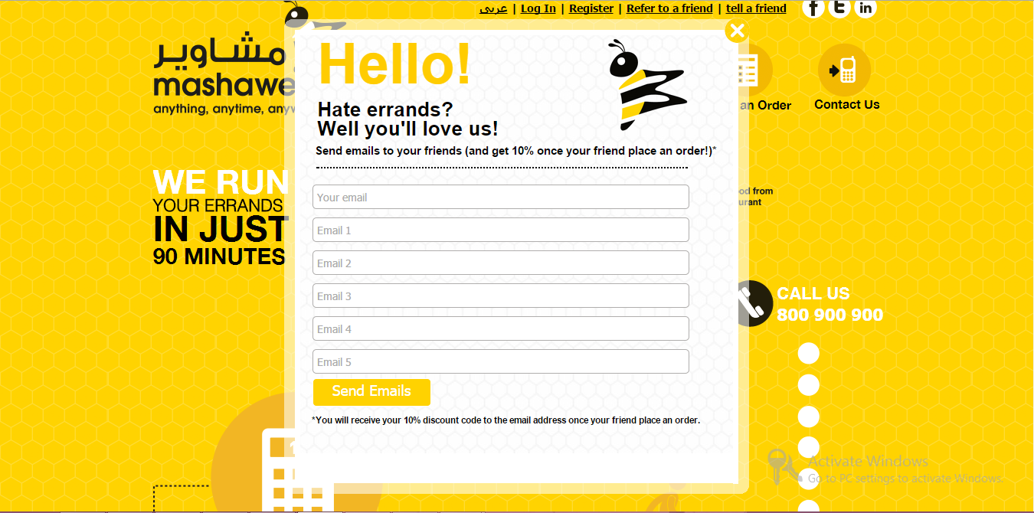

* Email Templates :
* After Customer Registration :

Dear (Customer Name)

Congratulations Mashaweer offers you 10% discount in your next place an order ,You can login with this email and use this promotion code “dgsiW7ir” to get discount and this offer is available from today until 16/3/2015 ,Click the below link and place your order http://mashaweeruae.com/Order.aspx

* After using promotion :

Dear (name)

You got mashaweer 10% discount on 10/2/2015 so you can’t use this promotion code “dgsiW7ir” again but you can get other discounts for each refer to friend that you will make once your friend place an order you will get bonus click on the below link and refer to friend now

http://mashaweeruae.com/

* After place an order if registered visitor :

Dear (name)

Congratulations Mashaweer offers you 10% discount for each refer to friend that you will make once your friend make place an order you will get bonus click on the below link and refer to friend now

http://mashaweeruae.com/

* If visitor make refer to friend ,His friend get this message :

Dear customer

Congratulations Mashaweer offers you 10% discount in your next place an order because Your Friend (name) Refer you to register and place an order in mashaweer ,You can login or place an order with this email and use this promotion code “dgsiW7ir” to get discount and this offer is available from today until 16/3/2015,Click the below link and place your order http://mashaweeruae.com/Order.aspx

* If friend place an order ,the visitor that make refer will get this message Whether visitor registered or not he will get bonus :

Dear (name)

Mashaweer offers you 10% discount in your next place an order because you refer to your friend to place an order in mashaweer so login or use this email to make place an order and get bonus, your promation code is “dgsiW7ir” and this offer is available from today until 16/3/2015,Click the below link and place your order and get bonus

<http://mashaweeruae.com/Order.aspx>

* If you aren’t registered user and made place an order ,you will get this message :

Dear customer

Congratulations Mashaweer offers you 10% discount in your next place an order if you make register now in our web site , Click the below link and register to get discount

[http://mashaweeruae.com/](http://mashaweeruae.com/Order.aspx)